**TASK REPORT**

**ALGORITHMS AND DATA STRUCTURE**

**WEEK 2**

**Created by:**

**Alexander Eko**

**L200220999**

**X**

**INFORMATICS ENGINEERING**

**FACULTY OF COMMUNICATION AND INFORMATICS**

**UNIVERSITAS MUHAMMADIYAH SURAKARTA**

**2023/2024**

**TASK**

1. **Addition of two variables**

a = 4

b = 5

c = a + b

print('Nilai a = ', a)

print('Nilai b = ', b)

print('Sekarang, c = a + b = ', a, '+', b, '=', c)

print('')

print('Sudah selesai.')

print('\n--- Oleh L220200999 ---')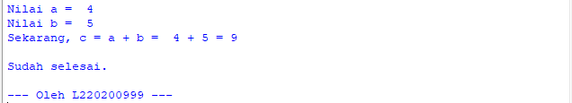

***\*notes:***

* Font size 12 px
* Every code and screenshot must be included (print) NIM.
* Format file name: NIM_Nama_ASD_TaskWeek2
* Example file name: L220200999_Alexander Eko_ASD_TaskWeek2
* Deadline: Wednesday 23.59 WIB